
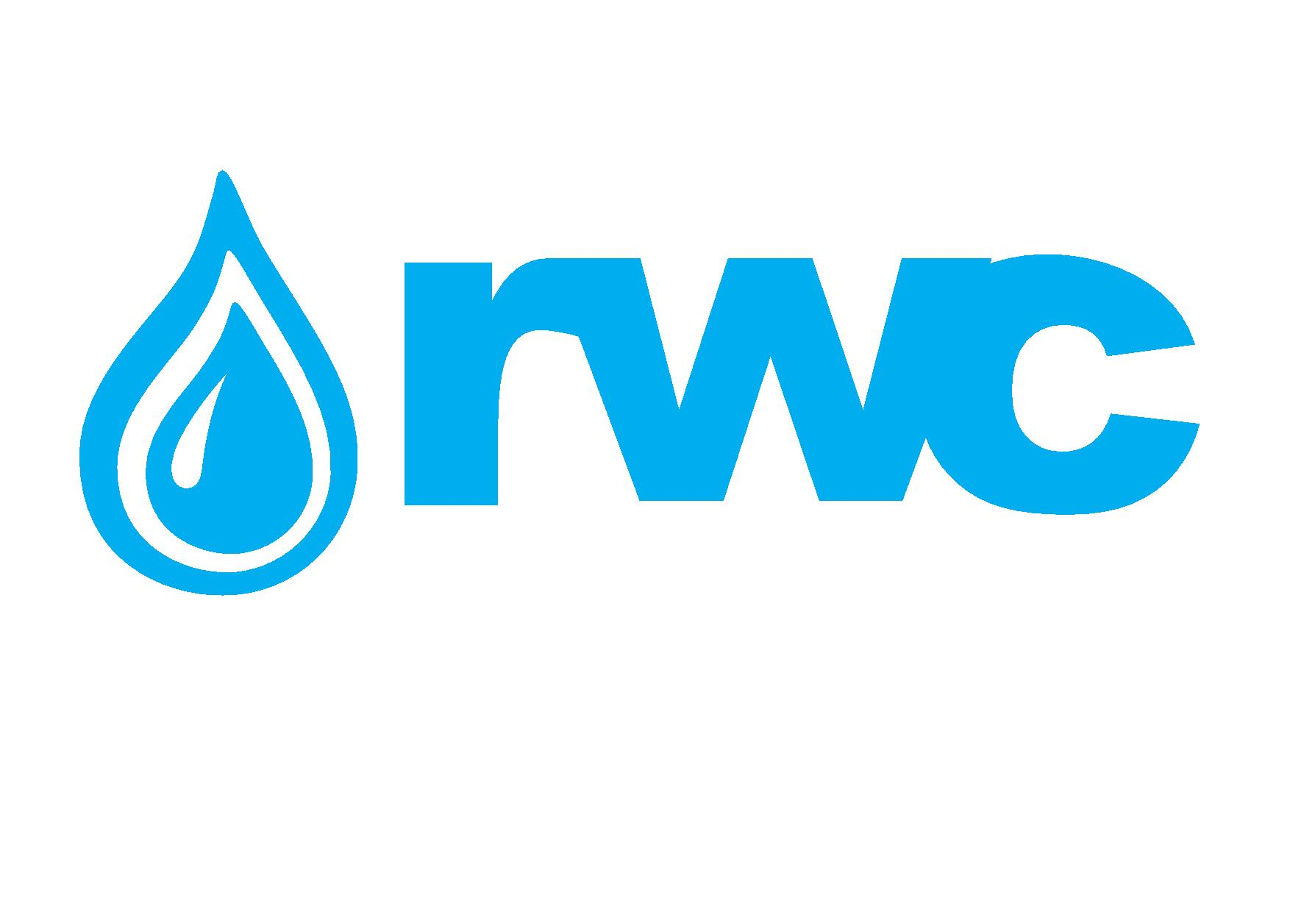

Request for Interest (RFI) for the procurement of PE 100 (Polyethylene) Pipes (Water, Sewerage) and Fittings

Introduction
“Georgian Water and Power” (GWP) is a leading company on the water supply market of Georgia and South Caucasus. The company provides high quality service to the population of Tbilisi, as well as to state organizations, industrial and commercial objects. More than 3000 company employees ensure delivering water and wastewater services to Tbilisi residents. Georgian Water and Power serves about 507 432 customers throughout the city Including - Residential 477 762; Nonresidential 29 670

“Rustavi Water”, together with “Georgian Water and Power” and “Mtskheta Water”, is a member of one and the same investment group, rendering water supply and drainage service to 49 932 customers in Rustavi, 4 713 customers – in Gardabani and 62 customers – in Marneuli, among them to budgetary organizations and commercial objects.

website: https://www.gwp.ge/

1.1 Object and Aim of RFI
Georgian Water and Power LLC(GWP) and Rustavi Water LLC(RWC) announces Request for Interest for the procurement of PE 100 (Polyethylene) Pipes (Water, Sewerage) and Fittings.

The types and yearly consumption of the materials (PE Pipes and Fittings) are given in annex N1

Note: After evaluating the offers submitted in the aforementioned RFI GWP/RWC will invite only the shortlisted Companies to its closed Electronic Tender, who satisfy all the terms and conditions identified by the RFI.

1.2 Purchaser’s (GWP/RWC) Commercial and Technical Requirements

Requirement | Sub-Requirement | Description
Payment Term | Post payment | Min. 30 Calendar Days, approximate limit up to 500,000 USD
Warranty &  Insurance | Guarantee Maintenance | Replacement of damaged pipe in case of Manufacturer's confirmed failure
 | Certificates | List of Required Certificates to be provided (Annex 4)

1.3 Interested Companies should present
1. Filled Annex N1, where shall be completely filled “Item Name by manufacturer” and “Image of sample” columns;
2. Completely filled Annex N2-Company Basic Information;
3. Written Consent to the Purchaser’s Commercial and Technical Requirements defined in article 1.2
4. Completely filled yellow highlighted fields given in Annex N3;
5. List of the certificates defined in Annex N4.
6. Additionally, shortlisted companies will be required to present
-Technical information regarding usage of Pipes,
-Pipe Technical data sheet,
-Transportation, Storage manual,
-Manual of Pipe installation,
-Testing guideline
1.4 Contact Information
Contact Person: Giorgi Asatiani
Procurement Specialist (Logistics and Procurement Department)
Address: Medea (Mzia) Jugeli st.N10, 0179 Tbilisi, Georgia
E-mail: giasatiani@gwp.ge
Web Page: www.gwp.ge
Te: +995 322 931 111 (1241)

Contact Person: Irakli Khvadagadze
Head of Logistics & Procurement Department
Address: Medea (Mzia) Jugeli st.N10, 0179 Tbilisi, Georgia
E-mail: ikhvadagadze@gwp.ge
Web Page: www.gwp.ge
Tel: +995 322 931 111 (1145)

